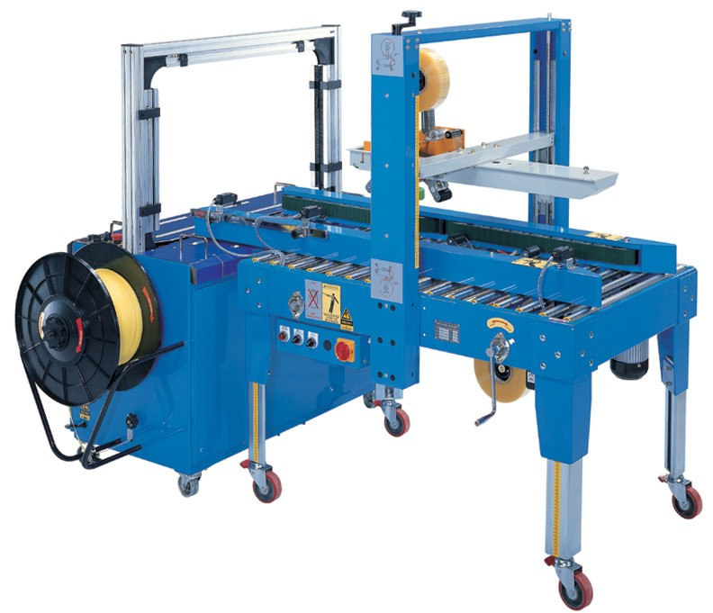

COMBO PACK KE 350 CS

AUTO CARTON SILLING AND STRAPPING

POWER SUPPLY ; - 3 PH 415 VOLT

SPEED ; - 300 CARTON PAR HOURS

TAPE WIDTH ;- 2” – 3” (48MM TO 72 MM )

STRAP WIDTH ;- 9 MM , 12 MM , 15 MM

CIRTON SIZE ;- W 200-500 MM \* H 120\*500 MM

AIR :- 6 KGF/CM2